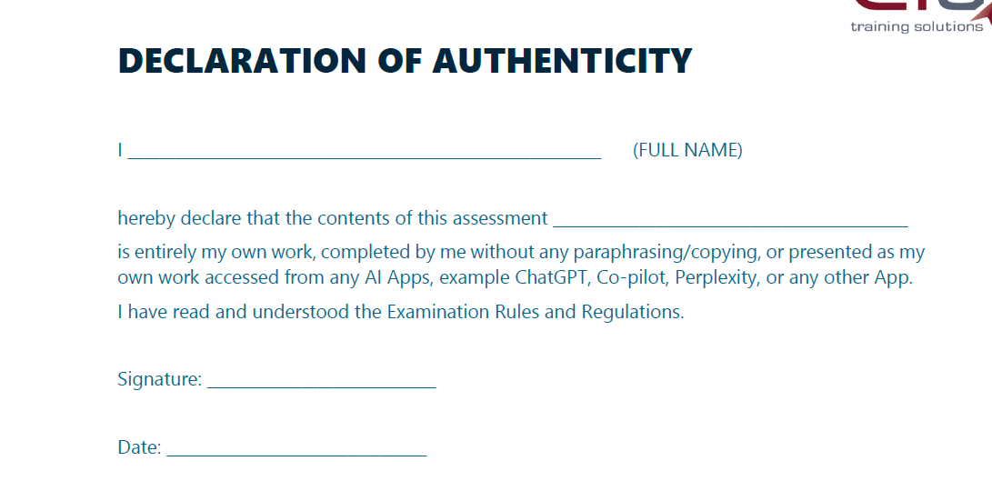

GitHub link:
https://github.com/Slixx01/SDT621-FA1

